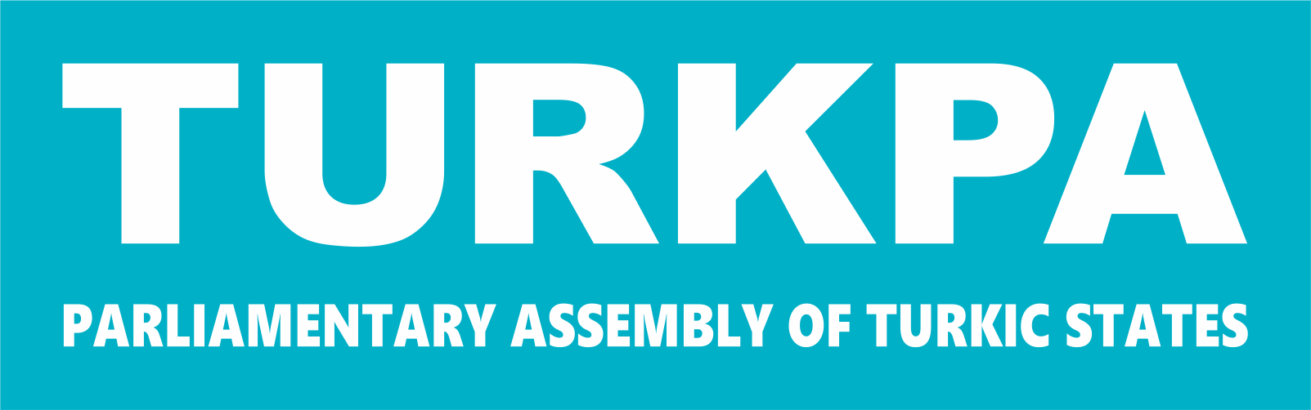
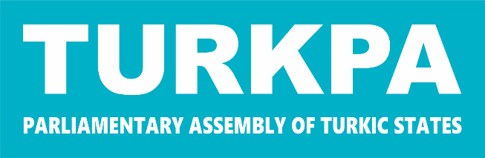

PARLIAMENTARY ASSEMBLY OF TURKIC STATES

ELEVENTH MEETING
OF THE TURKPA COMMISSION ON ENVIRONMENT, NATURAL RESOURCES AND HEALTH PROTECTION

RECOMMENDATIONS

21 May 2026

Ankara

“ENVIRONMENTAL POLLUTION IN TURKPA MEMBER STATES: CHALLENGES AND COOPERATION PROSPECTS”

The Parliamentary Assembly:

Fostering initiatives that enhance sustainable management of natural resources, conservation of biodiversity, and resilience to climate change;

Encouraging the adoption of low-carbon energy solutions and efficient waste management;

Supporting knowledge exchange to strengthen capacity in environmental governance, clean production, and climate adaptation;

Accelerating the development of national strategies, action plans, and regulatory frameworks to achieve sustainability targets;

Enhancing regional coordination on common environmental challenges such as climate change, air quality, water, and ecosystem protection;

Facilitating public awareness campaigns and educational programs to increase environmental participation and responsibility;

Recognizing the role of member parliaments in mobilizing resources, enacting legislation, and overseeing environmental initiatives;
Promoting stronger cooperation among TURKPA member states to advance sustainable development and environmental protection;

Recommends the parliaments of the TURKPA member states:

- to enhance the transition to renewable energy and low-carbon technologies, while supporting energy efficiency measures, in line with national circumstances and priorities;

- to encourage the sharing of knowledge, best practices, and practical experiences among member states in the field of zero waste management, including waste reduction, recycling, and circular economy approaches.

- to enhance technical cooperation in integrated wastewater management, including the planning, design, construction, and operation of wastewater treatment facilities.

- to accelerate circular economy initiatives, including zero waste programs, recycling, and reduction of single-use plastics;

- to support the dissemination of successful practices and policies, particularly Türkiye’s experience in combating desertification, land degradation, erosion, and drought, and encourage their adaptation and implementation in other member countries.

- to facilitate the exchange of expertise on sustainable sludge management, including treatment, disposal, and potential reuse, ensuring environmental safety and resource efficiency.

- to promote investment in green technologies, environmental innovation, and joint green programs;

- to foster biodiversity conservation, restoration of ecosystems, and climate-adaptive management of vulnerable species and habitats;

- to promote the adoption of clean production technologies, efficient water use, and the safe reuse of treated wastewater, particularly in industrial sectors.

j) to promote coordination among TURKPA member states on environmental emergencies and transboundary pollution;

k) to support collaborative research, technical training, and capacity-building in clean production and climate resilience;

