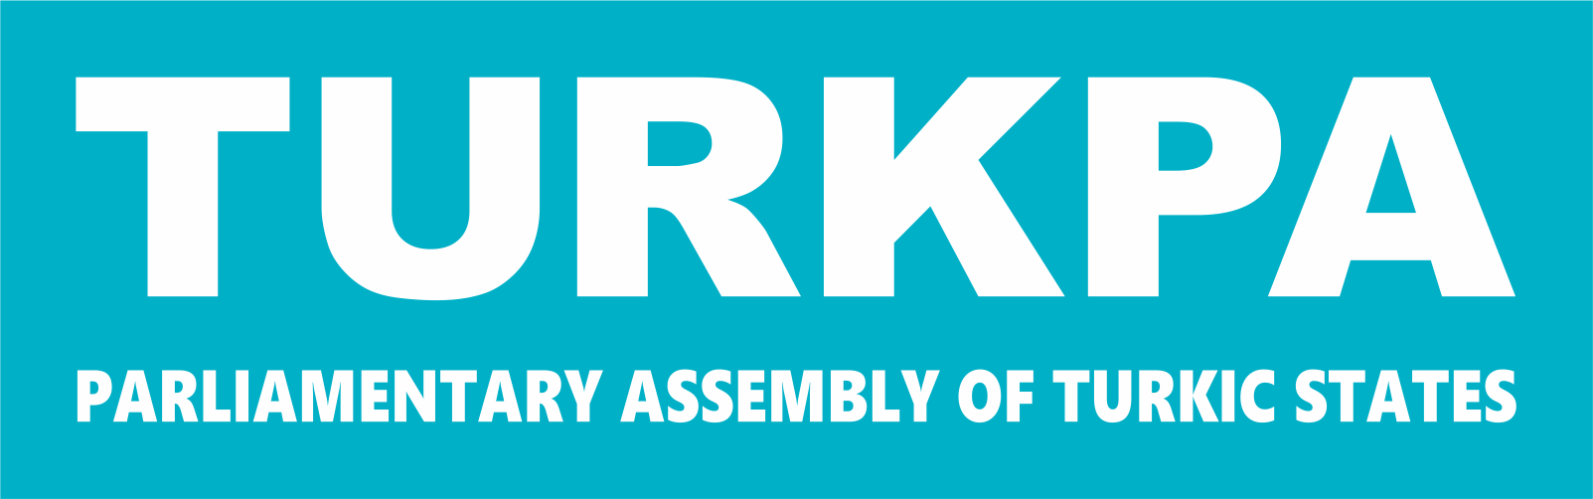

PARLIAMENTARY ASSEMBLY OF TURKIC STATES

COMMISSION ON LEGAL AFFAIRS AND INTERNATIONAL RELATIONS
THE THIRTEENTH MEETING

BISHKEK, KYRGYZ REPUBLIC
08.06.2026

RECOMMENDATION ON
“THE ROLE OF LOCAL ADMINISTRATIONS IN STRENGTHENING
REGIONAL COOPERATION AMONG
TURKPA MEMBER STATES”

The Parliamentary Assembly,

Recognizing the growing role of local administrations in strengthening regional cooperation among TURKPA Member States;
Acknowledging that, as the international system evolves into an increasingly multi-layered and multi-actor structure, local administrations have become effective actors of cross-border cooperation;
Bearing in mind that local administrations assume a complementary role in the fields of sustainable development, economic growth, environmental sustainability, and social cohesion;
Underscoring the increasing importance of international municipalism, city diplomacy, and resilient cities approaches;
Appreciating sister city relations, cooperation protocols, and international local administration networks as effective instruments supporting regional integration;
Taking into account that the participation of local administrations in international cooperation is encouraged within the framework of international norms and principles;
Welcoming the contributions of meetings and workshops organized within TURKPA to the development of inter-municipal cooperation;
Underlining that strengthening the institutional and technical capacities of local administrations is decisive for the effectiveness and sustainability of regional cooperation;

Recommends to the TURKPA Member Parliaments:
- to formulate comprehensive legal frameworks that will place the participation of local administrations in international cooperation on a clear, predictable, and sustainable basis, and to review existing legislation accordingly;
- to enhance the capacities of local administrations in international project development, implementation, and financial management through the expansion of training, technical assistance, and institutional development programmes;
- to transform sister city relations into a strategic, measurable, and results-oriented structure, and to link them with concrete projects, joint investments, and sustainable development goals;
- to introduce regular monitoring, evaluation, and reporting mechanisms in order to enhance the effectiveness of inter-municipal cooperation processes;
- to promote the creation of thematic cooperation networks in priority areas such as environment, climate change, digitalization, smart city applications, tourism, logistics, and sustainable urban development;
- to advance multilateral cooperation platforms among local administrations beyond bilateral relations, and to ensure their institutionalization;
- to reinforce coordination mechanisms between central authorities and local administrations in order to ensure that the international activities of local administrations are conducted in line with national foreign policy priorities;
- to elaborate common standards and to launch pilot projects in the fields of digital municipalities, data-driven governance, and smart city applications;
- to facilitate the effective utilization of the financing models of the Turkic Investment Fund in local administration projects aimed at enhancing social, cultural, and economic interaction across the Turkic world;
- to institutionalize the sharing of information and experience among local administrations, the establishment of a digital “Turkic World Local Administrations Cooperation Platform” within TURKPA;
- to organize joint training, drills and early warning mechanisms among local administrations in the fields of disaster management, humanitarian aid coordination and crisis-resilient urban planning;
- to support multi-stakeholder governance models that encourage cooperation between local administrations and universities, think tanks, development agencies and civil society organizations;
- to develop representation, internship, training and joint project programmes that ensure the more effective participation of youth and women in the international cooperation processes of local administrations;
- to promote inter-municipal cooperation mechanisms aimed at trade, investment, logistics corridors and regional production networks in order to strengthen intercity economic integration in the Turkic world;
- to initiate joint cultural diplomacy projects among local administrations aimed at the protection, restoration and international promotion of the common historical and cultural heritage;
- to establish joint consultancy, project pool and technical matching mechanisms that facilitate the access of local administrations to international funds;
- to create networks for the sharing of best practices among local administrations in the fields of environmental sustainability, water management, energy efficiency and zero-waste practices;
- to formulate common data infrastructures and comparative index studies regarding urban statistics, local development indicators and city performance measurements in the Turkic world;
- to institutionalize regular forums, meetings of mayors and thematic conferences under a structured calendar to ensure the continuity of cooperation in the field of local administrations under the auspices of TURKPA.

