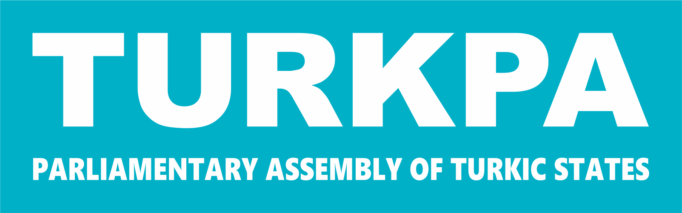

PARLIAMENTARY ASSEMBLY OF TURKIC STATES

COMMISSION ON ECONOMIC COOPERATION

THIRTEENTH MEETING

Baku, 7 April, 2026

RECOMMENDATION

REALITIES AND PROSPECTS OF CONDUCTING JOINT ECONOMIC ACTIVITIES OF TURKPA MEMBER STATES

The Parliamentary Assembly:

Understanding the need to use all available opportunities conducting joint economic activities of the TURKPA member countries for realizing the trade and economic potential;

Confirming the importance of continuing cooperation within all multilateral and regional organizations that support the contribution to joint economic cooperation in the TURKPA region;

Valuing the joint efforts of the TURKPA member states to promote economic cooperation in the region via enhanced trade, tourism, transport, and investment initiatives;

Emphasizing the importance of continuing green transformation and green finance initiatives in the economy in response to the challenges posed by climate change;

Showing readiness to implement within its competence all the initiatives of the Heads of State voiced within the framework of the Organization of Turkic States (OTS) aimed at the development and strengthening of the Turkic World, including those laid down in such strategic documents as the “Turkic World Vision – 2040” and “OTS Strategy for 2022-2026”;

Welcoming all mutual cooperation activities aimed at increasing and protecting mutual investments for purpose of strengthening the national economies of the TURKPA member states;

Realizing that in the increasingly complicated geopolitical and international trade and economic situation, the TURKPA cooperation should be focused on improving mutually beneficial trade and economic mechanisms;

Understanding the need to increase the transit potential through simplifying and digitizing customs procedures in order to create favorable conditions for the transit routes passing through the TURKPA territory established in the international treaties that approved by the TURKPA member countries;

Considering the special role of parliaments and parliamentarians in providing institutional, infrastructural and financial support for the development of all sectors of the national economy including trade, industry, production and transport by enacting legislation, approving budgets, mobilizing resources,

Recommends the parliaments of the TURKPA member countries:
- to improve the legal framework related to joint ventures, with subsequent harmonization and approximation of the legislation among the TURKPA member countries;
- to harmonize the legislation of TURKPA member countries aimed at integrating digital markets in e-commerce, including the exchange of electronic forms of documents related to e-commerce, mutual recognition of electronic certificates, digital payment of customs duties and fees, digital invoices and trade financing, digital logistics, etc.;
- to establish a harmonious legal framework among TURKPA member countries that will give the most positive impetus to increasing mutual and regional trade, as well as ensure full freedom in bilateral and transit traffic TURKPA between member countries;
- to support the effective operation of the Turkic Investment Fund in promoting intra-regional trade, reducing trade barriers, strengthening transport and logistics connectivity, and advancing physical and digital trade infrastructure;
- to assist in adopting an effective approach to ensure the regular operation of the OTS Trade Facilitation Committee in implementing projects in areas such as digital trading platforms, Single Window Systems, trade information portals, Customs Modernization, capacity building and paperless trade at the border;
- to support, within its competence, the adoption of the Industrial Cooperation Program of the Turkic Chamber of Commerce and Industry, which prioritizes specific projects as the main direction of integration in the industrial sector in order to diversify the economies of the Turkic States;
- to ensure the cooperation and exchange of experience between free zones and organized industrial zones in TURKPA member countries, such as the “TURANSEZ” special economic zone;
- to facilitate the completion of the internal ratification process in TURKPA member countries of the Digital Economy Partnership Agreement (DEPA), which regulates paperless trade, establishment of an electronic transaction framework, logistics, electronic invoicing, express delivery services, electronic payments, national supplier database, electronic signature, commercial electronic messages, online consumer protection, personal data protection, among other topics;
- to consider legal support for the active modernization of the infrastructure of air hubs, railway stations and seaports along the Middle Corridor in order to raise cooperation between the Turkic States in the field of transport and logistics to a new level;
- to participate in the discussion of the issue of creating a special Digital Monitoring Center within the Turkic States, focusing on the effectiveness of the use of artificial intelligence technologies as part of the ongoing work on the digitalization of the transport and transit sector;
- to provide legal support for the establishment of the Turkic States Digital Innovations Center, which will allow to exchange experience in the field of artificial intelligence and attract venture capital, aimed at supporting startups and developing joint projects within the framework of the Alem.ai Artificial Intelligence Center in Astana;
- to review the issues of establishing a Council for Energy Efficiency Excellence within the framework of the Organization of Turkic States, which will be an important mechanism for attracting investments in renewable energy sources in support of joint environmental initiatives to protect the environment in the region;
- to oversight of the effective implementation of measures aimed at adopting a joint program of the Turkic States, which includes new approaches to the effective use of water resources among the Turkic States, including the establishment of digital control over the irrigation system, the widespread use of drip irrigation methods, and increasing the efficiency of water reservoirs;
- to assist in the implementation of the Roadmap for Cooperation between the Turkic states in the field of Economy, Trade, Investment, and Finance, aimed at digitalization and trade integration;
- to promote the issues on the creation of a single economic space of the Turkic States, aimed at improving infrastructure, eliminating trade barriers and administrative obstacles, facilitate trade procedures, and strengthen economic policy coordination for cross-border trade and integration of economies.

